**HOSPITAL MANAGEMENT SYSTEM**

**CASE STUDY**

Hospital Management system helps in registering information about patients and handles patient’s query. A unique ID is generated for each patient after registration. This helps in implementing customer relationship management and also maintains medical history of patient. This system also monitors the doctor appointments, when the ID is generated the patient receives the appointment time and number from the receptionist and accordingly visit the doctor. This system also deals with deals with testing appointments as and when ID is generated the patient receives the appointment time and number and accordingly undergoes the test.

It also deals with bed allotments to various patients by checking their ID. It also undergoes various operations by diagnosing the patients. The system identifies whether the person is a doctor or staff and handles various activities such as draw salary and give salary, also it adds doctor/staff information into database. This system is responsible for handling various other activities like deleting, editing doctor/staff information into the database. As per doctor diagnoses the patient, gives treatment and gives suggestions to patients and prescribe laboratory tests and medicines.

This system also takes care of medical equipment, doctor visit, vitals recording, patient case sheet, diet ordering, blood requisition, transfer information and discharge information, maintenance of wards, inter and intra wards transfers also it generates patient’s discharge summary which includes patient’s health at the time of discharge, medical history, various diagnosis and drug prescriptions, history of patient’s illness and course in hospital. Patient can pay bill through credit card, cash or cheque whose information is maintained by this system.

**USE CASE DIAGRAM**

1. **Use Case:** Use case diagram shows the general processes or function that the system could do that is based on the transactions done by the patient and physician whether it is admission or consultation for Hospital Management System. The use case diagrams depict the system’s main components as well as the flow of information between them. With the help of this use case, the programmer will have the basis on what could be put into consideration in creating the hospital management system.
2. **Monitor and Manage Patients’ Information and Status:** This is where the admin or the main user of the system could have access into the patient information in terms of availing the hospital services. The patients’ information must be composed of their basic data, sickness complaints or consultations including admission. These data were then recorded and given to the appropriate physician for curing and basis for the kind of services to be done.
3. **Manage Hospital Rooms and Physicians’ Info and Status:** This is the process where the admin checks and update the room information and status because is important for patient admission. It is important to secure the rooms before admitting the patients because the patients must put into delicate care. By this process, the admin will organize the processes during the patient admission.
4. **Monitor Hospital Transaction Records:** This process explains about how the admin or users handles transaction made by the physician and the client. These transactions were composed of the patients’ information and sickness complaints and the physician that has accommodated that patient, the prescription provided and the total payment of the said transaction.

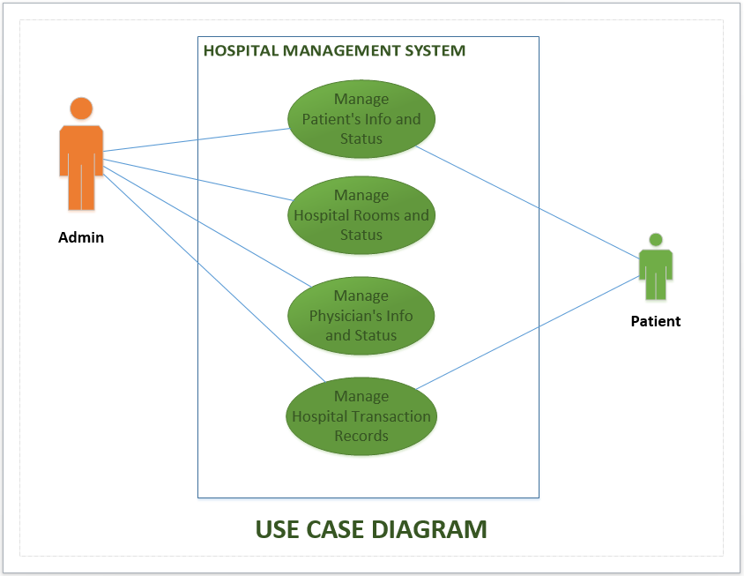

**Activity Diagram Scenario**

Now, here’s a design UML activity diagram design for two users in hospital management system. It was made to give you a sample situation when there are two users are involving in a certain activity. For example, when discharging a patient, the admission bill and treatment must be monitored. So it is a must that you design first the core flow of the software before developing it.

**Action of Activity Diagram**

1. First user of hospital is patient. Patients start by showing the list of services which is provided by Hospital Management Systems.
2. Hospital management show patient information.
3. Patient admission payment.
4. Hospital Admin action for admission cost and provide to Management. Management calculate and provide information to admin. Hospital admin approved the discharge.
5. Patient pay the bill.
6. Management update the patient information.
7. Save the transaction and provide to admin.
8. Management receive payment and release receipt.
9. End the transaction activity.

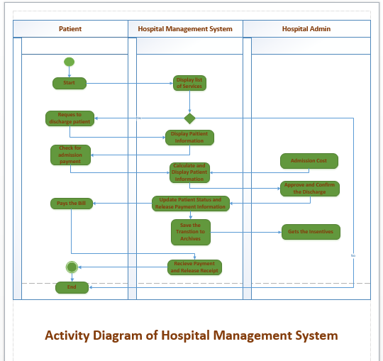

**Sequence Diagram Scenario**

Graphically a sequence diagram is a table that shows objects arranged along the x-axis and messages ordered in increasing time along the y-axis patient discharge doctor registration reception laboratory pharmacy summary login view appointments register send request done any surgeries go to laboratory take medicine send discharge summary discharge patient 16 hospital management system.

Element of Sequence Diagram:

1. There are four object lifeline in this diagram. They are Patient object, Doctor object, Operation object and Test object.
2. Sequence diagram present activation with activation diagram of object lifeline.
3. -----> show return message and block arrow head line show message in sequence diagram.
4. Patient activation complete with operation.

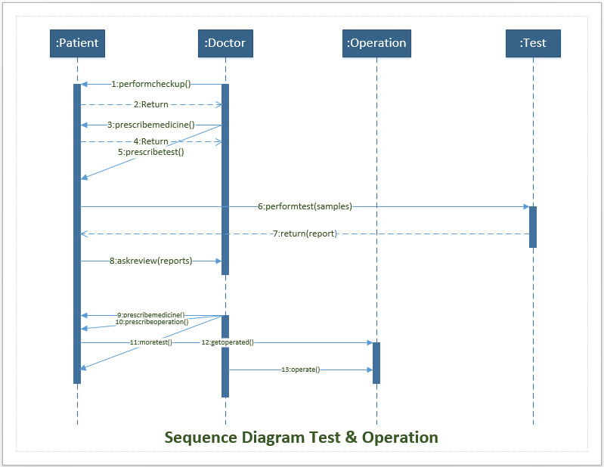

Class Diagram Description

The Diagram for Hospital Management System, you will first determine the classes. So the classes that must be made in a Hospital are the patients, users, physicians and nurses, admission and transaction. The mentioned classes were just general. If you want more complex or wider scope of your Hospital management system, then you can add your desired classes. You must also include the database on your Class Diagram for your system. It resembles a flowchart in which classes are represented as boxes with three rectangles inside each box. The top rectangle has the class’s name; the middle rectangle contains the class’s properties; and the bottom rectangle contains the class’s methods, commonly known as operations.

Class Name which are included the diagram

1. Patient class
2. Admission class
3. Transaction class
4. Physician class
5. Medicine class
6. Prescription class
7. Admin Class

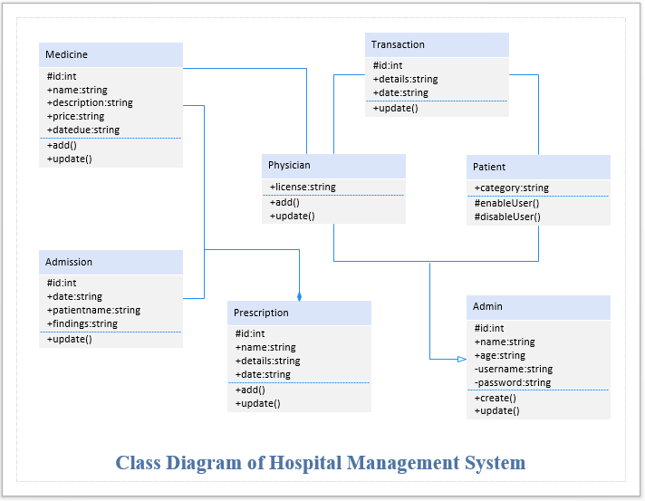

**State Chart Diagram**

A state diagram consists of states, transitions, events, and activities. You use state diagrams to illustrate the dynamic view of a system. They are especially important in modeling the behavior of an interface, class, or collaboration.

The Figure below shows the key elements of a state diagram in UML. This notation permits you to visualize the behavior of an object in a way that lets you emphasize the important elements in the life of that object.

**Behavior of State Chart Diagram:**

1. A **state** is a condition or situation during the life of an object during which it satisfies some condition, performs some activity, or waits for some event.
2. An **action**is an executable atomic computation that results in a change in the state of the model or the return of a value.

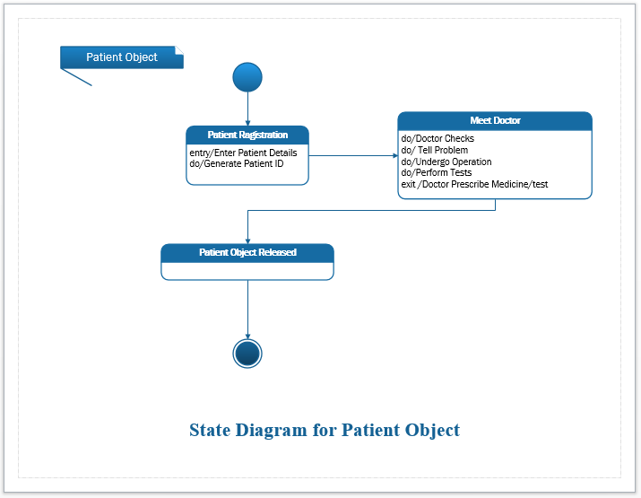

**Class Responsibility Collaboration(CRC)**

Class-responsibility-collaboration cards are a brainstorming tool used in the design of object-oriented software. They were originally proposed by Ward Cunningham and Kent Beck as a teaching tool, but are also popular among expert designers and recommended by extreme programming supporters.

**CRC Cards** generated with responsibility of object and collaborate to other class/object. They are described shortly.

**Responsibility of objects and collaborations:**

1. **Patients:** Patients provide their information and submit to the management and collaborate payment.
2. **Admission:** Admission provide patient admission time information and add collaborate physician.
3. **Transaction:** Provide information of patient transaction and collaborate to admin and physician.
4. **Medicine:** Provide information of medicine and collaborate to physician and patient.
5. **Physician:** Provide information of physician and add information of patient and calculate transaction add collaborate admin.
6. **Prescription:** Prescription provide information and status of patient and detail medicine for patient.
7. **Admin:** Admin manage transaction and approved transaction, manage physician information, manage patient information and records.

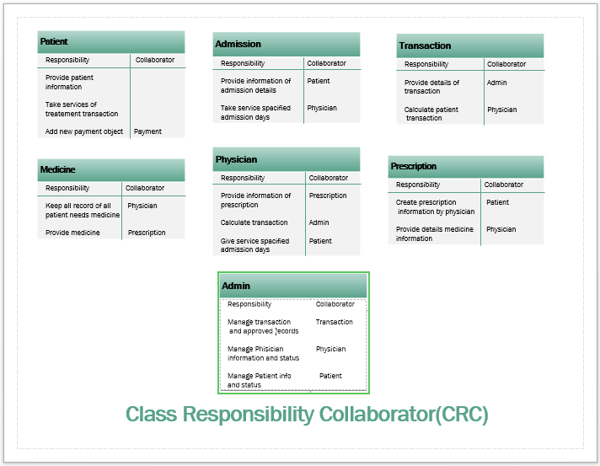

**THE END**